the solution to production planning problem of mechanical products

**Question Definition**

A Machinery Factory produces 7 products (from No.1 to No.7). The factory owns the following equipment: four grinding machines, two vertical spindles, three horizontal spindles, one boring machine and one [planer](javascript:;). The profit of each product (CNY/unit, profit is the difference between the selling price and the cost of raw materials) And the working hours of various equipment needed to produce the unit's products are listed in table 1. “—" means the product doesn’t require the equipment to produce.

Table 1. Product profit (CNY/unit) and required equipment working hours(hours/unit)

|  |  |  |  |  |  |  |  |
| --- | --- | --- | --- | --- | --- | --- | --- |
| Product | No.1 | No.2 | No.3 | No.4 | No.5 | No.6 | N0.7 |
| Unit profit | 10.00 | 6.00 | 3.00 | 4.00 | 1.00 | 9.00 | 3.00 |
| grinding machines | 0.5 | 0.7 | - | - | 0.3 | 0.2 | 0.5 |
| vertical spindles | 0.1 | 2 | - | 0.3 | - | 0.6 | - |
| horizontal spindles | 0.2 | 6 | 0.8 | - | - | - | 0.6 |
| boring machine | 0.05 | 0.02 | - | 0.0.7 | 0.1 | - | 0.08 |
| planer | - | - | 0.01 | - | 0.05 | - | 0.05 |

From January to June, in each month the following equipment needs to be maintained (in the month that it is maintained, the equipment cannot be in use for production). It is listed in table 2.

Tabel 2. Product maintenance plan

|  |  |
| --- | --- |
| Month | # of Equipment |
| Jan. | one grinding machine |
| Feb. | two vertical spindles |
| Mar. | one boring machine |
| Apr. | one vertical spindle |
| May | One grinding machine and one vertical spindle |
| Jun. | One planer and one horizontal spindle |

Table 3.The upper limit for sales of each product

|  |  |  |  |  |  |  |  |
| --- | --- | --- | --- | --- | --- | --- | --- |
| Product | 1 | 2 | 3 | 4 | 5 | 6 | 7 |
| Jan. | 500 | 1000 | 300 | 300 | 800 | 200 | 100 |
| Feb. | 600 | 500 | 200 | 0 | 400 | 300 | 150 |
| Mar. | 300 | 600 | 0 | 0 | 500 | 400 | 100 |
| Apr. | 200 | 300 | 400 | 500 | 200 | 0 | 100 |
| May | 0 | 100 | 500 | 100 | 1000 | 300 | 0 |
| Jun. | 500 | 500 | 100 | 300 | 1100 | 500 | 60 |

The largest inventory for each product is 100 units，and the price for inventory is 0.5 CNY/unit. In the beginning of January, there’s no stock for all the products. While at the end of June, there must be 50 pieces for each product in stock. The factory runs two shifts a day，8 hours for each. Suppose they work for 23 days each month.

Q1. Specify a 6 - month production, inventory, and sales plan to maximize total profits for the 6 - month period.

Q2. Without changing the above plan, which products can be sold at higher prices in a few months to increase profits? How much has the price gone up?

Q3. Which equipment capacity should be increased? Please prioritize the purchase of new equipment.

Q4. Is it possible to increase profits by adjusting maintenance schedules for existing equipment? Put forward a new equipment maintenance plan, so that the original planned maintenance of equipment in this half a year can get the maintenance and the profit should be increased as much as possible.

Q5. To construct an optimal equipment maintenance plan model, which maximizes the profit by making the number of equipment maintenance meet the requirements in the case.

**Modeling**

The question is a linear programming problem. With Lingo, I can build up the model and get the optimal solution. And with sensitivity analysis, I can find the shadow price to increase the profit. The difficulty of this problem is in its multiple variables. Thus, establishing constraint conditions is the key to solve this problem.

（1）Setting variables

Production：suppose producing No. j product in month i and the # is Xij, i=1,2,3…; j=1,2,3…;

Sales：suppose selling No. j product in month i and the # is Sij, i=1,2,3…; j=1,2,3…;

Stock ：suppose putting No. j product in stock in month i and the # is Yij, i=1,2,3…; j=1,2,3…;

（2）Objective function is (z is the total profit)：

z=10×+6×+3×+4×+1×+9×+3×- 0.5×

（3）constraints

1)constraint of production

a. required working hours

A=(aij)=

i=1,2,…5 representing grinding machines, vertical spindles, horizontal spindles, boring machine and [planer](javascript:;).

j=1,2,…7, representing 7 products.

b.the largest working hour that the equipment can provide each month

B=(bij)=

i=1,2,…5 representing grinding machines, vertical spindles, horizontal spindles, boring machine and [planer](javascript:;).

j=1,2,…7, representing 7 products。

c. the matrix for production is

X=(Xij)=

Because the working hour cannot exceed the largest working hour that the equipment can provide each month:

A*X<=B

So the inequality constraints are:

Jan.

grinding machine：0.5X11+0.7X12+0.3X15+0.2X16+0.5X17<=3*368

vertical spindle：0.1X11+2X12+0.3X14+0.6X16<=2*368

horizontal spindle: 0.2X11+6X12+0.8X13+0.6X17<=3*368

boring machine：0.05X11+0.02X12+0.07X14+0.1X15+0.08X17<=1*368

planer：0.01X13+0.05X15+0.05X17<=1*368

Feb.

grinding machine： 0.5X21+0.7X22+0.3X25+0.2X26+0.5X27<=4*368

vertical spindle: 0.1X21+2X22+0.3X24+0.6X26<=0

horizontal spindle：0.2X21+6X22+0.8X23+0.6X27<=3*368

boring machine：0.05X21+0.02X22+0.07X24+0.1X25+0.08X27<=1*368

planer：0.01X23+0.05X25+0.05X27<=1*368

Mar.

grinding machine：0.5X31+0.7X32+0.3X35+0.2X36+0.5X37<=4*368

vertical spindle：0.1X31+2X32+0.3X34+0.6X36<=2*368

horizontal spindle：0.2X31+6X32+0.8X33+0.6X37<=3*368

boring machine：0.05X31+0.02X32+0.07X34+0.1X35+0.08X37<=0

planer：0.01X33+0.05X35+0.05X37<=1*368

Apr.

grinding machine：0.5X41+0.7X42+0.3X45+0.2X46+0.5X47<=4*368

vertical spindle：0.1X41+2X42+0.3X44+0.6X46<=1*368

horizontal spindle：0.2X41+6X42+0.8X43+0.6X47<=3*368

boring machine：0.05X41+0.02X42+0.07X44+0.1X45+0.08X47<=1*368

planer：0.01X43+0.05X45+0.05X47<=1*368

May

grinding machine：0.5X51+0.7X52+0.3X55+0.2X56+0.5X57<=3*368

vertical spindle：0.1X51+2X52+0.3X54+0.6X56<=1*368

horizontal spindle：0.2X51+6X52+0.8X53+0.6X57<=3*368

boring machine：0.05X51+0.02X52+0.07X54+0.1X55+0.08X57<=1*368

planer：0.01X53+0.05X55+0.05X57<=1*368

June

grinding machine：0.5X61+0.7X62+0.3X65+0.2X66+0.5X67<=4*368

vertical spindle：0.1X61+2X62+0.3X64+0.6X66<=2*368

horizontal spindle：0.2X61+6X62+0.8X63+0.6X67<=2*368

boring machine：0.05X61+0.02X62+0.07X64+0.1X65+0.08X67<=1*368

planer：0.01X63+0.05X65+0.05X67<=0

2）inventory constraints

The limit for stock is 100 each month，so Yij<=100, i=1,2,…5, j=1,2,…7

At the end of June the stock should be larger than 50 for each product，so Y6j>=50

Inventory number:

X1j-S1j=Y1j

Y1j+X2j-S2j=Y2j

……

Y5j+X6j-S6j=Y6j

3）Sales constraints:

D=(dij)=

Sij<=dij i=1,2,…6,j=1,2,…7

Xij>=0

Sij>=0

Yij>=0

**3. Programming and solution**

sets:

machine/1..5/;

product/1..7/:INTREST;

month/1..6/;

links1(machine,product):NT;

links2(machine,month):AT;

links3(product,month):A,C,UPSALE,B;

endsets

data:

INTREST=10 6 3 4 1 9 3;

NT=0.5 0.7 0 0 0.3 0.2 0.5

0.1 2.0 0 0.3 0 0.6 0

0.2 6.0 0.8 0 0 0 0.6

0.05 0.02 0 0.07 0.1 0 0.08

0 0 0.01 0 0.05 0 0.05;

AT=1104 736 1104 368 368

1472 0 1104 368 368

1472 736 1104 0 368

1472 368 1104 368 368

1104 368 1104 368 368

1472 736 736 368 0;

UPSALE=500 1000 300 300 800 200 100

600 500 200 0 400 300 150

300 600 0 0 500 400 100

200 300 400 500 200 0 100

0 100 500 100 1000 300 0

500 500 100 300 1100 500 60;

enddata

max=@sum(product(i):INTREST*(@sum(month(j):A(i,j))))-5*@sum(links3(i,j):B(i,j));

@for(links2(i,m):@sum(product(j):NT(i,j)*A(j,m))<=AT(i,m));

@for(links3(i,j):B(i,j)<=100);

@for(links3(i,j):B(i,6)=50);

@for(product(i):A(i,1)-B(i,1)=C(i,1));

@for(links3(i,j)|j#NE#1:A(i,j)+B(i,j-1)-C(i,j)=B(i,j));

@for(links3(i,j):C(i,j)<=UPSALE(i,j));

End

Q1: Specify a six - month production, inventory, and sales plan to maximize total profits for the six - month period.

According to the result of program, the highest profits that it can generate is 41293

The production plan is：

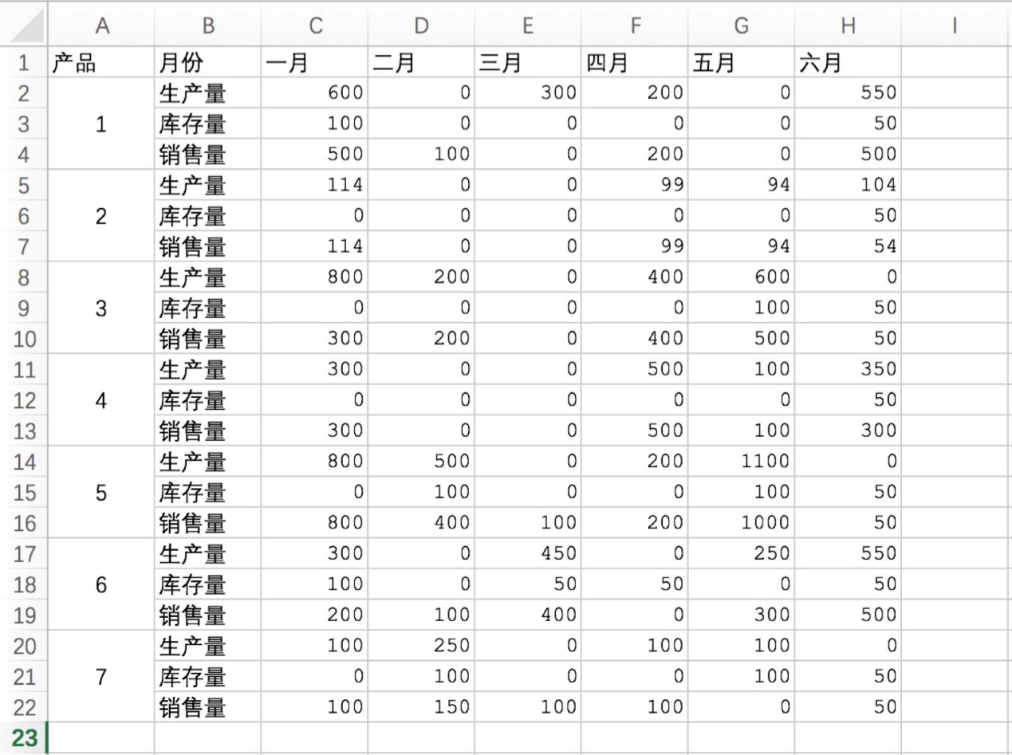

Q2. Without changing the above plan, which products can be sold at higher prices in a few months to increase profits? How much has the price gone up?

When the production plan doesn’t change, the optimal plan won’t change. According to sensitive analysis, we can tell the range that the price can increase. In the sensitive report provided by LINGO,

ALLOWABLE INCREASES show the range that the parameter can increase, which indicates the range of profit that it can increase.

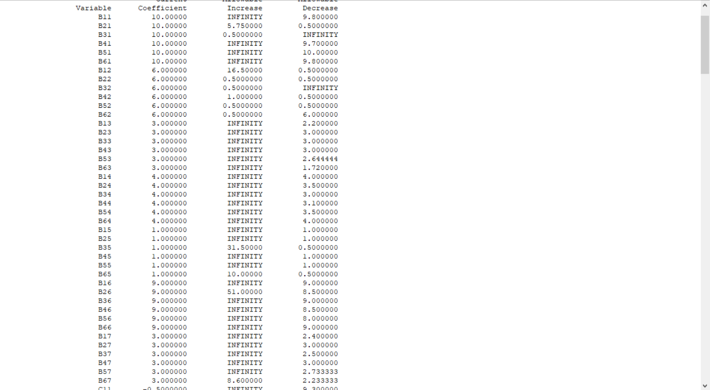

Therefore, searching for the Allowable Increase of variable B, we can get the table of

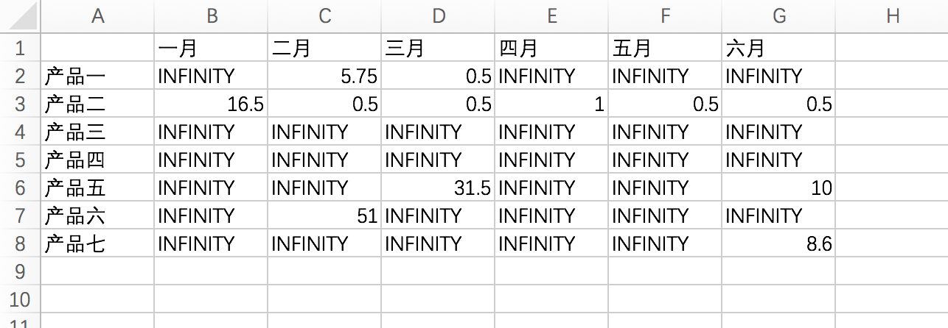

INFINITY means that the selling price can increase as much as possible, while numbers mean that the selling price can only increase this much.

Q3. Which equipment capacity should be increased? Please prioritize the purchase of new equipment.

The shadow price reflects how the equipment increases profit, so equipment with higher shadow

should be improved. The dual price in LINGO reflects the attribute.

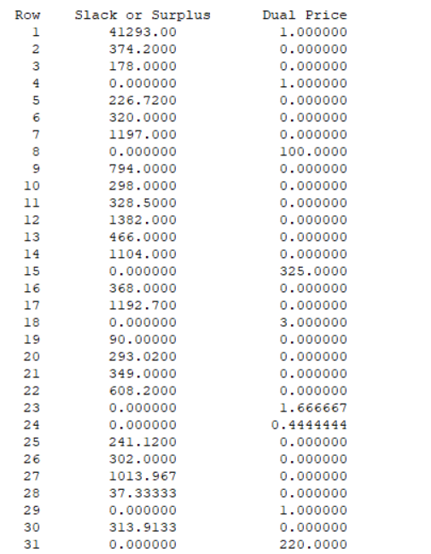

Therefore, the shadow price for each product in each month is :

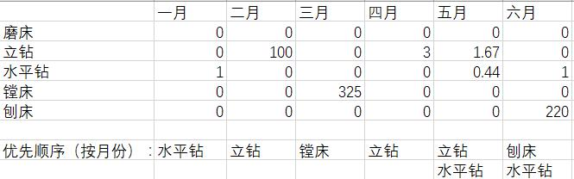

From the table we can see:

In January, we should buy horizontal spindle. In January, we should buy vertical spindle. In March, we should buy boring machine. In April, we should buy vertical spindle. In May, we should buy vertical spindle, horizontal spindle. In June, we should buy planer and horizontal spindle.

Q4. Is it possible to increase profits by adjusting maintenance schedules for existing equipment? Put forward a new equipment maintenance plan, so that the original planned maintenance of equipment in this half a year can get the maintenance and the profit should be increased as much as possible.

Analysis：

Set variable: Mij, i is the rank of equipment; j is rank of months, i=1,2,…5, j=1,2,…6

1)Working hour constraints:

Total Working Time(NT)+Maintenance Time(M)<=The maximum time that an equipment can provide(AT)

A=(aij)=

X=(Xij)=

B1=(bij)=

Maintenance Time(M)：

M=(mij)=

AX+M<=B1

2) The original equipment should be repaired in the new maintenance plan, so the total number of equipment in the original six months should be equal to the total number of new maintenance equipment

# of equipment constraints：

=4

=2

=3

=1

=1

LINGO program

model:

sets:

machine/1..5/;

product/1..7/:INTREST;

month/1..6/;

links1(machine,product):NT;

links2(machine,month):AT;

links3(product,month):A,C,UPSALE,B;

endsets

data:

INTREST=10 6 3 4 1 0 9 3;

NT=0.5 0.7 0 0 0.3 0.2 0.5

0.1 2.0 0 0.3 0 0.6 0

0.2 6.0 0.8 0 0 0 0.6

0.05 0.02 0 0.07 0.1 0 0.08

0 0 0.01 0 0.05 0 0.05;

AT=1104 1472 1472 1104 1472

736 0 736 368 368 736

1104 1104 1104 1104 1104 736

368 368 0 368 368 368

368 368 368 368 368 0;

UPSALE=500 1000 300 300 800 200 100

600 500 200 0 400 300 150

300 600 0 0 500 400 100

200 300 400 500 200 0 100

0 100 500 100 1000 300 0

500 500 100 300 1100 500 60;

enddata

max=@sum(product(i):INTREST*(@sum(month(j):A(i,j))))-5*@sum(links3(i,j):B(i,j));

@for(links2(i,m):@sum(product(j):NT(i,j)*A(j,m))<=AT(i,m));

@for(links3(i,j):B(i,j)<=100);

@for(links3(i,j):B(i,6)=50);

@for(product(i):A(i,1)-B(i,1)=C(i,1));

@for(links3(i,j)|j#NE#1:A(i,j)+B(i,j-1)-C(i,j)=B(i,j));

@for(links3(i,j):C(i,j)<=UPSALE(i,j));

According to program results,

The new maximum profit is：52247.33

The best maintenance plan is:

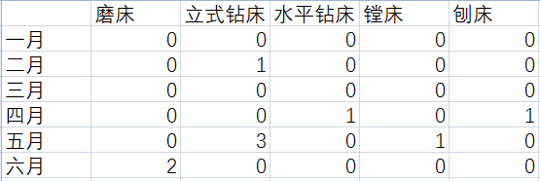

Which is also the answer to question 5

**4. Results of coding**

Results of question 1-3:

Global optimal solution found.

Objective value: 41293.00

Infeasibilities: 0.000000

Total solver iterations: 29

Variable Value Reduced Cost

B11 500.0000 0.000000

B21 100.0000 0.000000

B31 0.000000 0.5000000

B41 200.0000 0.000000

B51 0.000000 0.000000

B61 500.0000 0.000000

B12 114.0000 0.000000

B22 0.000000 0.000000

B32 0.000000 0.5000000

B42 99.00000 0.000000

B52 94.00000 0.000000

B62 54.33333 0.000000

B13 300.0000 0.000000

B23 200.0000 0.000000

B33 0.000000 0.000000

B43 400.0000 0.000000

B53 500.0000 0.000000

B63 50.00000 0.000000

B14 300.0000 0.000000

B24 0.000000 0.000000

B34 0.000000 0.000000

B44 500.0000 0.000000

B54 100.0000 0.000000

B64 300.0000 0.000000

B15 800.0000 0.000000

B25 400.0000 0.000000

B35 100.0000 0.000000

B45 200.0000 0.000000

B55 1000.000 0.000000

B65 50.00000 0.000000

B16 200.0000 0.000000

B26 100.0000 0.000000

B36 400.0000 0.000000

B46 0.000000 0.000000

B56 300.0000 0.000000

B66 500.0000 0.000000

B17 100.0000 0.000000

B27 150.0000 0.000000

B37 100.0000 0.000000

B47 100.0000 0.000000

B57 0.000000 0.000000

B67 50.00000 0.000000

C11 100.0000 0.000000

C12 0.000000 0.5000000

C13 0.000000 1.300000

C14 0.000000 0.000000

C15 0.000000 0.5000000

C16 100.0000 0.000000

C17 0.000000 1.100000

C21 0.000000 0.000000

C22 0.000000 0.000000

C23 0.000000 0.5000000

C24 0.000000 0.000000

C25 100.0000 0.000000

C26 0.000000 9.500000

C27 100.0000 0.000000

C31 0.000000 10.70000

C32 0.000000 1.000000

C33 0.000000 0.5000000

C34 0.000000 0.6000000

C35 0.000000 1.500000

C36 50.00000 0.000000

C37 0.000000 1.000000

C41 0.000000 0.8000000

C42 0.000000 0.5000000

C43 0.000000 0.1444444

C44 0.000000 0.9000000

C45 0.000000 0.5000000

C46 50.00000 0.000000

C47 0.000000 0.2333333

C51 0.000000 0.3000000

C52 0.000000 0.5000000

C53 100.0000 0.000000

C54 0.000000 1.000000

C55 100.0000 0.000000

C56 0.000000 1.500000

C57 100.0000 0.000000

C61 50.00000 0.000000

C62 50.00000 0.000000

C63 50.00000 0.000000

C64 50.00000 0.000000

C65 50.00000 0.000000

C66 50.00000 0.000000

C67 50.00000 0.000000

A11 600.0000 0.000000

A12 114.0000 0.000000

A15 800.0000 0.000000

A16 300.0000 0.000000

A17 100.0000 0.000000

A14 300.0000 0.000000

A13 300.0000 0.000000

A21 0.000000 0.000000

A22 0.000000 194.0000

A25 500.0000 0.000000

A26 0.000000 51.00000

A27 250.0000 0.000000

A24 0.000000 29.50000

A23 200.0000 0.000000

A31 0.000000 5.750000

A32 0.000000 0.000000

A35 0.000000 31.50000

A36 450.0000 0.000000

A37 0.000000 25.50000

A34 0.000000 21.75000

A33 0.000000 0.000000

A41 200.0000 0.000000

A42 99.00000 0.000000

A45 200.0000 0.000000

A46 0.000000 1.300000

A47 100.0000 0.000000

A44 500.0000 0.000000

A43 400.0000 0.000000

A51 0.000000 0.2555556

A52 94.00000 0.000000

A55 1100.000 0.000000

A56 250.0000 0.000000

A57 100.0000 0.000000

A54 100.0000 0.000000

A53 600.0000 0.000000

A61 550.0000 0.000000

A62 104.3333 0.000000

A65 0.000000 10.00000

A66 550.0000 0.000000

A64 350.0000 0.000000

A63 0.000000 0.000000

A67 0.000000 8.600000

Row Slack or Surplus Dual Price

1 41293.00 1.000000

2 0.000000 9.800000

3 886.0000 0.000000

4 0.000000 2.200000

5 0.000000 4.000000

6 0.000000 1.000000

7 0.000000 9.000000

8 0.000000 2.400000

9 500.0000 0.000000

10 500.0000 0.000000

11 0.000000 3.000000

12 0.000000 3.500000

13 0.000000 1.000000

14 200.0000 0.000000

15 0.000000 3.000000

16 300.0000 0.000000

17 600.0000 0.000000

18 0.000000 3.000000

19 0.000000 3.000000

20 400.0000 0.000000

21 0.000000 9.000000

22 0.000000 2.500000

23 0.000000 9.700000

24 201.0000 0.000000

25 0.000000 3.000000

26 0.000000 3.100000

27 0.000000 1.000000

28 0.000000 8.500000

29 0.000000 3.000000

30 0.000000 10.00000

31 6.000000 0.000000

32 0.000000 2.644444

33 0.000000 3.500000

34 0.000000 1.000000

35 0.000000 8.000000

36 0.000000 2.733333

37 0.000000 9.800000

38 445.6667 0.000000

39 50.00000 0.000000

40 0.000000 4.000000

41 1050.000 0.000000

42 0.000000 9.000000

43 10.00000 0.000000

44 374.2000 0.000000

45 178.0000 0.000000

46 0.000000 1.000000

47 226.7200 0.000000

48 320.0000 0.000000

49 1197.000 0.000000

50 0.000000 100.0000

51 794.0000 0.000000

52 298.0000 0.000000

53 328.5000 0.000000

54 1382.000 0.000000

55 466.0000 0.000000

56 1104.000 0.000000

57 0.000000 325.0000

58 368.0000 0.000000

59 1192.700 0.000000

60 0.000000 3.000000

61 90.00000 0.000000

62 293.0200 0.000000

63 349.0000 0.000000

64 608.2000 0.000000

65 0.000000 1.666667

66 0.000000 0.4444444

67 241.1200 0.000000

68 302.0000 0.000000

69 1013.967 0.000000

70 37.33333 0.000000

71 0.000000 1.000000

72 313.9133 0.000000

73 0.000000 220.0000

74 0.000000 9.300000

75 100.0000 0.000000

76 100.0000 0.000000

77 100.0000 0.000000

78 100.0000 0.000000

79 0.000000 8.500000

80 100.0000 0.000000

81 100.0000 0.000000

82 100.0000 0.000000

83 100.0000 0.000000

84 100.0000 0.000000

85 0.000000 0.5000000

86 100.0000 0.000000

87 0.000000 0.000000

88 100.0000 0.000000

89 100.0000 0.000000

90 100.0000 0.000000

91 100.0000 0.000000

92 100.0000 0.000000

93 50.00000 0.000000

94 100.0000 0.000000

95 100.0000 0.000000

96 100.0000 0.000000

97 100.0000 0.000000

98 100.0000 0.000000

99 100.0000 0.000000

100 50.00000 0.000000

101 100.0000 0.000000

102 100.0000 0.000000

103 100.0000 0.000000

104 0.000000 2.144444

105 100.0000 0.000000

106 0.000000 0.5000000

107 100.0000 0.000000

108 0.000000 2.233333

109 0.000000 -0.7000000

110 0.000000 -6.500000

111 0.000000 -3.500000

112 0.000000 -0.5000000

113 0.000000 -1.500000

114 0.000000 -0.5000000

115 0.000000 -3.500000

116 0.000000 -0.2000000

117 0.000000 -6.000000

118 0.000000 -0.8000000

119 0.000000 0.000000

120 0.000000 0.000000

121 0.000000 0.000000

122 0.000000 -0.6000000

123 0.000000 -10.00000

124 0.000000 -6.000000

125 0.000000 0.000000

126 0.000000 -0.5000000

127 0.000000 0.000000

128 0.000000 -9.000000

129 0.000000 0.000000

130 0.000000 -10.50000

131 0.000000 -6.500000

132 0.000000 0.000000

133 0.000000 -1.000000

134 0.000000 -1.000000

135 0.000000 0.000000

136 0.000000 -0.5000000

137 0.000000 -0.3000000

138 0.000000 -6.000000

139 0.000000 0.000000

140 0.000000 -0.9000000

141 0.000000 0.000000

142 0.000000 -0.5000000

143 0.000000 0.000000

144 0.000000 0.000000

145 0.000000 -6.000000

146 0.000000 -0.3555556

147 0.000000 -0.5000000

148 0.000000 0.000000

149 0.000000 -1.000000

150 0.000000 -0.2666667

151 0.000000 -0.2000000

152 0.000000 -6.000000

153 0.000000 -3.000000

154 0.000000 0.000000

155 0.000000 -1.000000

156 0.000000 0.000000

157 0.000000 -3.000000

Results of question 4:

Global optimal solution found.

Objective value: 52247.33

Objective bound: 52247.33

Infeasibilities: 0.1148237E-12

Extended solver steps: 5

Total solver iterations: 653

Variable Value Reduced Cost

B11 500.0000 0.000000

B21 600.0000 0.000000

B31 300.0000 0.000000

B41 200.0000 0.000000

B51 0.000000 0.000000

B61 500.0000 0.000000

B12 54.00000 0.000000

B22 64.00000 0.000000

B32 174.0000 0.000000

B42 99.00000 0.000000

B52 0.000000 0.000000

B62 98.00000 0.000000

B13 300.0000 0.000000

B23 200.0000 0.000000

B33 0.000000 0.000000

B43 400.0000 0.000000

B53 500.0000 0.000000

B63 100.0000 0.000000

B14 300.0000 0.000000

B24 0.000000 0.000000

B34 0.000000 0.000000

B44 500.0000 0.000000

B54 100.0000 0.000000

B64 300.0000 0.000000

B15 800.0000 0.000000

B25 400.0000 0.000000

B35 100.0000 0.000000

B45 200.0000 0.000000

B55 100.0000 0.000000

B65 1100.000 0.000000

B16 200.0000 0.000000

B26 300.0000 0.000000

B36 400.0000 0.000000

B46 0.000000 0.000000

B56 300.0000 0.000000

B66 500.0000 0.000000

B17 100.0000 0.000000

B27 150.0000 0.000000

B37 100.0000 0.000000

B47 100.0000 0.000000

B57 0.000000 0.000000

B67 60.00000 0.000000

C11 0.000000 0.5000000

C12 0.000000 0.5000000

C13 0.000000 0.5000000

C14 0.000000 1.900000

C15 0.000000 0.5000000

C16 0.000000 0.5000000

C17 0.000000 0.5000000

C21 0.000000 0.6000000

C22 0.000000 0.5000000

C23 0.000000 0.000000

C24 0.000000 0.000000

C25 100.0000 0.000000

C26 0.000000 2.300000

C27 100.0000 0.000000

C31 0.000000 0.4000000

C32 0.000000 0.5000000

C33 0.000000 1.000000

C34 100.0000 0.000000

C35 0.000000 1.500000

C36 0.000000 0.5000000

C37 0.000000 1.000000

C41 0.000000 0.000000

C42 0.000000 0.5000000

C43 0.000000 0.5000000

C44 100.0000 0.000000

C45 100.0000 0.000000

C46 0.000000 0.5000000

C47 0.000000 0.000000

C51 0.000000 1.072222

C52 0.000000 0.5000000

C53 100.0000 0.000000

C54 0.000000 1.650000

C55 0.000000 1.500000

C56 83.33333 0.000000

C57 0.000000 0.5666667

C61 50.00000 0.000000

C62 50.00000 0.000000

C63 50.00000 0.000000

C64 50.00000 0.000000

C65 50.00000 0.000000

C66 50.00000 0.000000

C67 50.00000 0.000000

A11 500.0000 0.000000

A12 54.00000 0.000000

A15 800.0000 0.000000

A16 200.0000 0.000000

A17 100.0000 0.000000

M11 0.000000 0.000000

A14 300.0000 0.000000

M12 1.000000 1104.000

A13 300.0000 0.000000

M13 1.000000 0.000000

M14 0.000000 0.000000

M15 0.000000 0.000000

A21 600.0000 0.000000

A22 64.00000 0.000000

A25 500.0000 0.000000

A26 300.0000 0.000000

A27 250.0000 0.000000

M21 0.000000 0.000000

A24 0.000000 1.400000

M22 1.000000 1104.000

A23 200.0000 0.000000

M23 0.000000 0.000000

M24 0.000000 0.000000

M25 0.000000 0.000000

A31 300.0000 0.000000

A32 174.0000 0.000000

A35 0.000000 0.000000

A36 400.0000 0.000000

A37 0.000000 1.100000

M31 0.000000 0.000000

A34 100.0000 0.000000

M32 0.000000 0.000000

A33 0.000000 0.5000000

M33 0.000000 368.0000

M34 0.000000 0.000000

M35 1.000000 7360.000

A41 200.0000 0.000000

A42 99.00000 0.000000

A45 300.0000 0.000000

A46 0.000000 1.800000

A47 100.0000 0.000000

M41 0.000000 0.000000

A44 500.0000 0.000000

M42 1.000000 1104.000

A43 400.0000 0.000000

M43 0.000000 0.000000

M44 0.000000 0.000000

M45 0.000000 0.000000

A51 0.000000 14.20000

A52 0.000000 0.000000

A55 0.000000 29.00000

A56 383.3333 0.000000

A57 0.000000 23.50000

M51 2.000000 0.000000

A54 0.000000 19.60000

M52 1.000000 0.000000

A53 600.0000 0.000000

M53 0.000000 0.000000

M54 1.000000 110400.0

M55 0.000000 0.000000

A61 550.0000 0.000000

A62 148.0000 0.000000

A65 1150.000 0.000000

A66 466.6667 0.000000

M61 0.000000 0.000000

A64 350.0000 0.000000

M62 0.000000 306.6667

A63 50.00000 0.000000

A67 110.0000 0.000000

M63 0.000000 265.7778

M64 0.000000 0.000000

M65 0.000000 0.000000

Row Slack or Surplus Dual Price

1 52247.33 1.000000

2 0.000000 9.700000

3 946.0000 0.000000

4 0.000000 3.000000

5 0.000000 3.100000

6 0.000000 1.000000

7 0.000000 7.200000

8 0.000000 3.000000

9 0.000000 9.700000

10 436.0000 0.000000

11 0.000000 3.000000

12 0.000000 4.500000

13 0.000000 1.000000

14 0.000000 7.200000

15 0.000000 3.000000

16 0.000000 9.800000

17 426.0000 0.000000

18 0.000000 2.500000

19 0.000000 4.000000

20 400.0000 0.000000

21 0.000000 9.000000

22 0.000000 2.500000

23 0.000000 9.700000

24 201.0000 0.000000

25 0.000000 3.000000

26 0.000000 3.100000

27 0.000000 1.000000

28 0.000000 9.000000

29 0.000000 3.000000

30 0.000000 9.200000

31 100.0000 0.000000

32 0.000000 3.000000

33 0.000000 2.600000

34 900.0000 0.000000

35 0.000000 9.000000

36 0.000000 2.500000

37 0.000000 9.772222

38 402.0000 0.000000

39 0.000000 2.422222

40 0.000000 3.750000

41 0.000000 1.000000

42 0.000000 8.500000

43 0.000000 2.566667

44 854.2000 0.000000

45 0.000000 3.000000

46 12.00000 0.000000

47 232.9200 0.000000

48 320.0000 0.000000

49 792.2000 0.000000

50 0.000000 3.000000

51 290.0000 0.000000

52 266.7200 0.000000

53 328.5000 0.000000

54 1120.200 0.000000

55 88.00000 0.000000

56 0.000000 1.000000

57 342.5200 0.000000

58 0.000000 20.00000

59 1162.700 0.000000

60 0.000000 3.000000

61 90.00000 0.000000

62 283.0200 0.000000

63 344.0000 0.000000

64 659.3333 0.000000

65 138.0000 0.000000

66 624.0000 0.000000

67 0.000000 300.0000

68 362.0000 0.000000

69 655.0667 0.000000

70 0.000000 0.8333333

71 0.000000 0.7222222

72 189.2400 0.000000

73 304.5000 0.000000

74 0.000000 0.000000

75 0.000000 0.000000

76 0.000000 0.000000

77 0.000000 0.000000

78 0.000000 0.000000

79 100.0000 0.000000

80 100.0000 0.000000

81 100.0000 0.000000

82 100.0000 0.000000

83 100.0000 0.000000

84 100.0000 0.000000

85 100.0000 0.000000

86 100.0000 0.000000

87 100.0000 0.000000

88 100.0000 0.000000

89 100.0000 0.000000

90 0.000000 0.5000000

91 100.0000 0.000000

92 0.000000 0.000000

93 100.0000 0.000000

94 100.0000 0.000000

95 100.0000 0.000000

96 0.000000 0.4000000

97 100.0000 0.000000

98 100.0000 0.000000

99 100.0000 0.000000

100 100.0000 0.000000

101 100.0000 0.000000

102 100.0000 0.000000

103 0.000000 0.000000

104 0.000000 0.5000000

105 100.0000 0.000000

106 100.0000 0.000000

107 100.0000 0.000000

108 100.0000 0.000000

109 0.000000 0.7777778E-01

110 100.0000 0.000000

111 100.0000 0.000000

112 16.66667 0.000000

113 100.0000 0.000000

114 0.000000 -0.7277778

115 0.000000 -6.500000

116 0.000000 -1.077778

117 0.000000 -0.7500000

118 0.000000 -0.5000000

119 0.000000 -1.000000

120 0.000000 -0.9333333

121 0.000000 -0.3000000

122 0.000000 -6.000000

123 0.000000 0.000000

124 0.000000 -0.9000000

125 0.000000 0.000000

126 0.000000 -1.800000

127 0.000000 0.000000

128 0.000000 -0.3000000

129 0.000000 -6.000000

130 0.000000 0.000000

131 0.000000 0.5000000

132 0.000000 0.000000

133 0.000000 -1.800000

134 0.000000 0.000000

135 0.000000 -0.2000000

136 0.000000 -6.000000

137 0.000000 -0.5000000

138 0.000000 0.000000

139 0.000000 -1.000000

140 0.000000 0.000000

141 0.000000 -0.5000000

142 0.000000 -0.3000000

143 0.000000 -6.000000

144 0.000000 0.000000

145 0.000000 -0.9000000

146 0.000000 0.000000

147 0.000000 0.000000

148 0.000000 0.000000

149 0.000000 -0.8000000

150 0.000000 -6.000000

151 0.000000 0.000000

152 0.000000 -1.400000

153 0.000000 -1.000000

154 0.000000 0.000000

155 0.000000 -0.5000000

156 0.000000 -0.2277778

157 0.000000 -6.000000

158 0.000000 -0.5777778

159 0.000000 -0.2500000

160 0.000000 0.000000

161 0.000000 -0.5000000

162 0.000000 -0.4333333